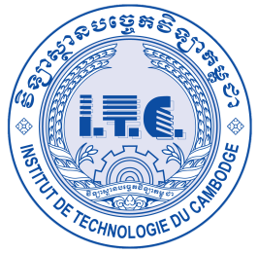

វិទ្យាស្ថានបច្ចេកវិទ្យាកម្ពុជា

InstitutE OF TechnologY OF CambodIA

Graduate school

Master’s Degree of Engineering

in

Mechatronics, Information and Communication Engineering

**PATH PLANNING and control OF WHEELED MOBILE ROBOT with OCCUPANCY GRID MAP**

A thesis submitted by

**YONRITH Phayuth**

Under co-supervision of

Dr. SRANG Sarot, Mr. SAKAL Morokot

JULY 2021

**PATH PLANNING and control OF WHEELED MOBILE ROBOT WITH OCCUPANCY GRID MAP**

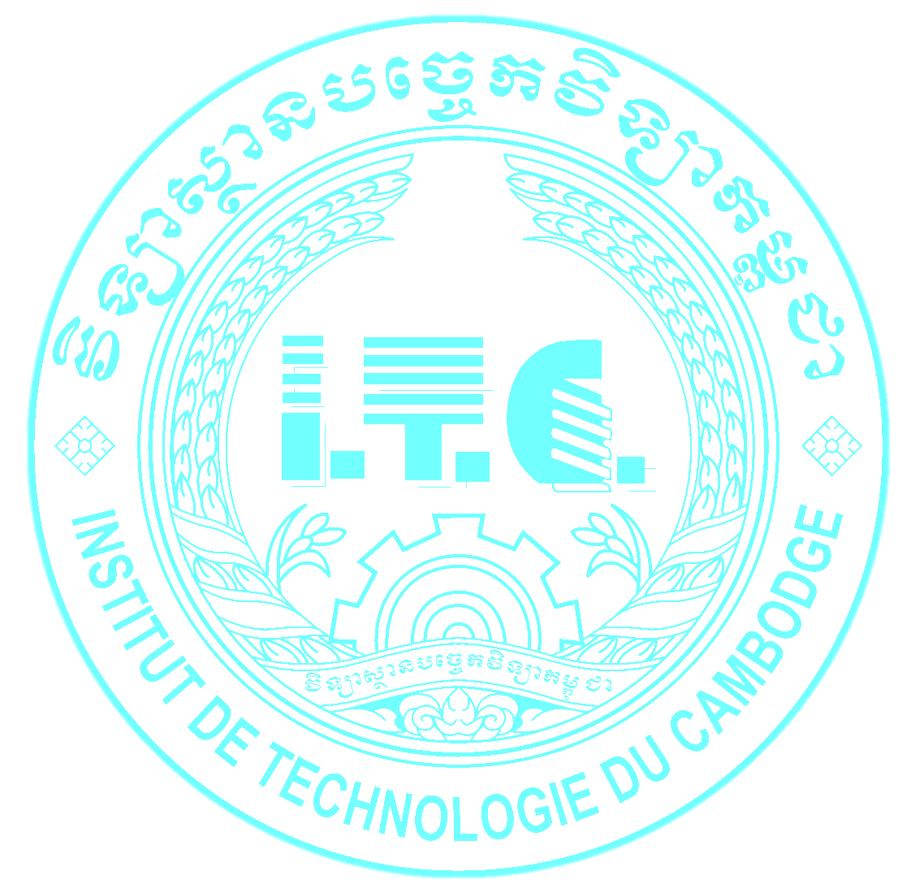

A THESIS PRESENTED BY

**YONRITH Phayuth**

TO

THE INSTITUTE OF TECHNOLOGY OF CAMBODIA

IN PARTIAL FULFILMENT OF THE REQUIREMENTS

FOR THE AWARD OF

MASTER’S DEGREE OF ENGINEERING

Specialization: ***Mechatronics, Information and Communication Engineering***

SUPERVISOR: **Dr. SRANG Sarot**

CO-SUPERVISOR: **Mr. SAKAL Morokot**

EXAMINATION COMMITTEE

**Dr. SIM Tepmony,** PhD, Lecturer, ITC *Chair*

**Dr. CHRIN Phok,** PhD, Lecturer, ITC *Reviewer*

**Dr. KIM Bunthern,** PhD, Lecturer, ITC *Reviewer*

**Dr. PEC Rothna,** PhD, Lecturer, ITC *Reporter*

**Dr. SRANG Sarot,** PhD, Lecturer, ITC *Member*

Phnom Penh, July 19, 2021

**Graduate School**

**Institute of Technology of Cambodia**

Russian Federation Boulevard, P.O. Box 86 Phnom Penh, Cambodia

Email: graduate@itc.edu.kh